**Parth Jadav**

**SQL Assignment with Task:-**

**Q1.1. Create Table Name : Student and Exam**

**Ans:-**

* **Student table**

Queries:-

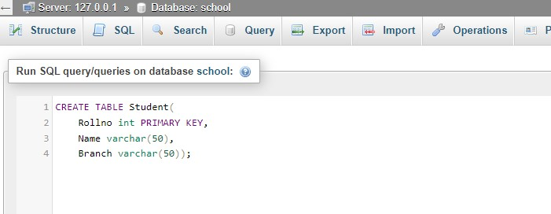

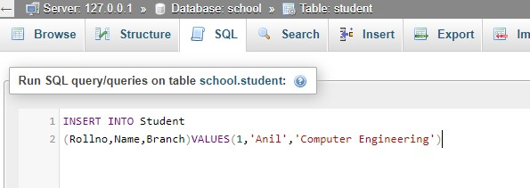

* **CREATE TABLE STUDENT :-**

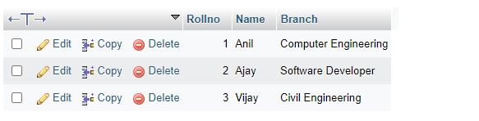

* **Exam table**

**Queries:-**

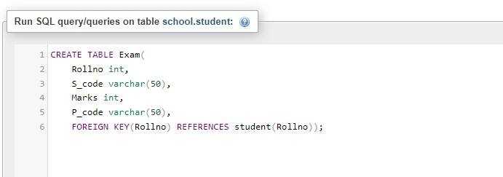

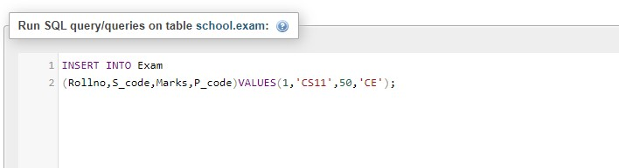

* **CREATE TABLE EXAM :-**

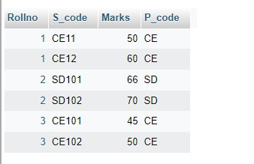

**Q.2. Create table given below**

**Queries:-**

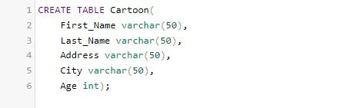

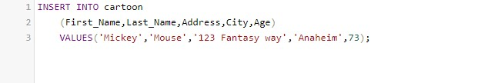

* **CREATES TABLE CARTOON :-**

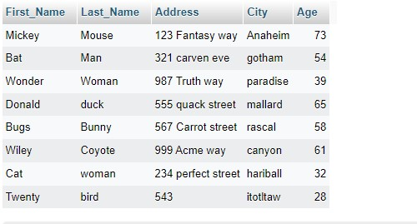

**Q.3.Create table given below: Employee and Incentive**

**Ans :-**

* **Table Employee**

**Queries :-**

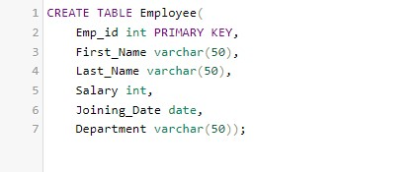

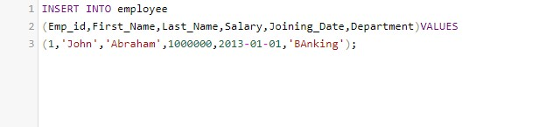

* **Table Creates**

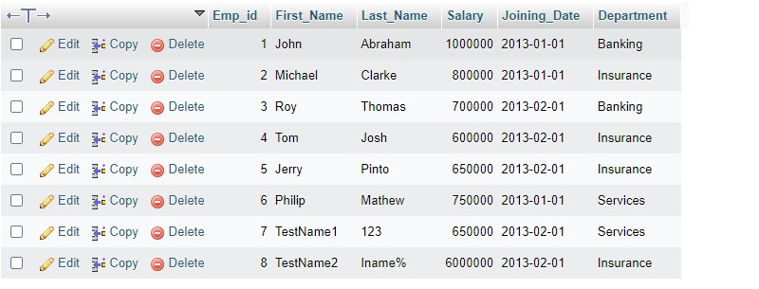

* **Incentives**

**Queries:-**

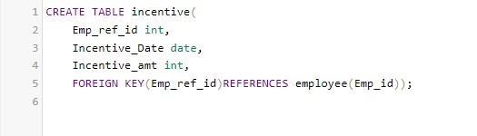

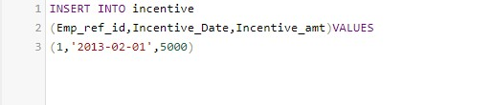

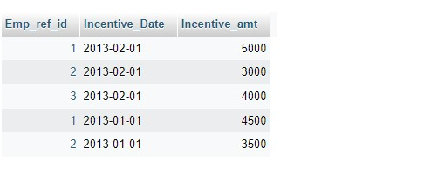

1. **Get First_Name from employee table using Tom name “Employee Name**

**Queries :-**



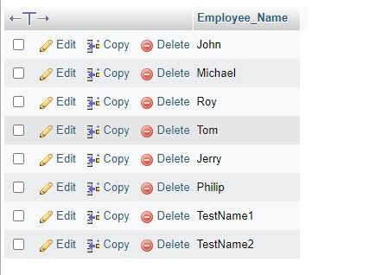

1. **Get FIRST_NAME, Joining Date, and Salary from employee table.**

**Queries :-**



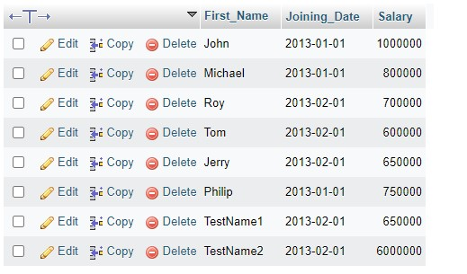

1. **Get all employee details from the employee table order by First_Name Ascending and Salary descending?**

**Queries :-**

* **Sort by First name ( Ascending )**



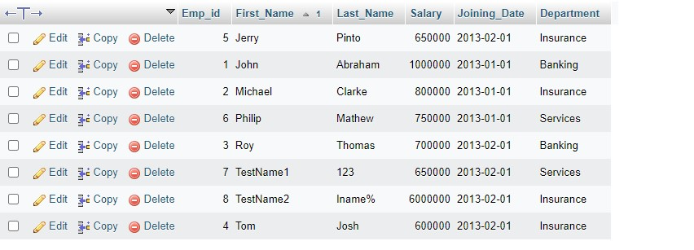

**Sort by salary ( Discending )**



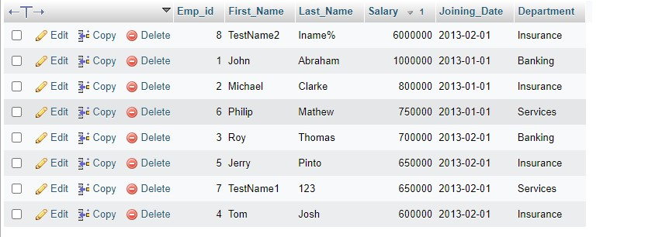

1. **Get employee details from employee table whose first name contains ‘J’.**

**Queries:-**



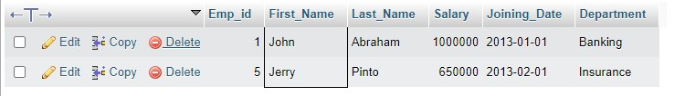

1. **Get department wise maximum salary from employee table order by salary ascending?**

**Queries:-**



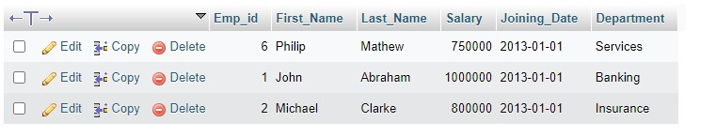

1. **Select first_name, incentive amount from employee and incentives table for those employees who have incentives and incentive amount greater than 3000**

**Queries :-**



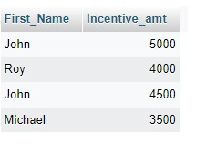

1. **Create After Insert trigger on Employee table which insert records in view table**

**Queries :-**

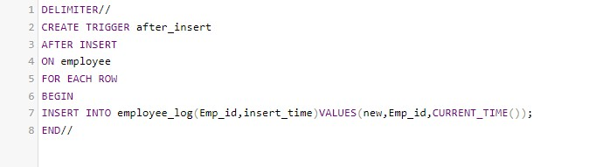

**Q. 4) Create table given below: Salesperson and Customer**

* **Sales person table**

**Queries : -**

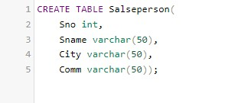

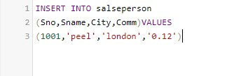

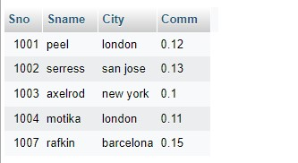

* **Table customer**

**Queries:-**

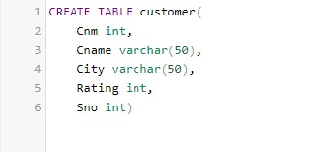

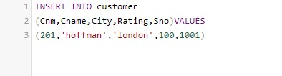

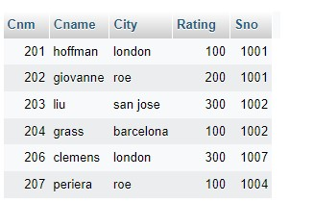

1. **All orders for more than $1000.**

* **Queries can’t match ( Empty result )**

1. **Names and cities of all salespeople in London with commission above 0.12**





1. **All salespeople either in Barcelona or in London**



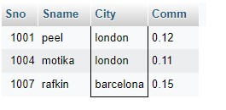

1. **All salespeople with commission between 0.10 and 0.12. (Boundary values should be excluded).**



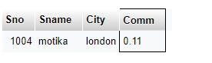

1. **All customers excluding those with rating <= 100 unless they are located in Roe**



